**A**

**Case Study Report Submission**

**On**

# Verizon – Enhancing Customer Experience with Tableau

**For**

**the partial fulfillment of II/I B. Tech. Course. Internal Assessment**

**of sdc Lab under the guidance of**

**Mrs.swarnalatha**



**By**

|  |  |  |
| --- | --- | --- |
| **SLNO.** | **HT NO.** | **STUDENT NAME** |
| **1** | **22WJ8A05TN** | **V Vineeth Reddy** |
|  |  |  |
|  |  |  |
|  |  |  |
|  |  |  |
|  |  |  |



**Ibrahimpatnam (M), R.R (Dt.)-501506, Hyderabad, Telangana, India.**

**2022-2023**

INDEX

|  |  |  |
| --- | --- | --- |
| SL.NO. | PERTICULARS | PAGE NO. |
| 1 |  | 1-5 |
| 2 |  | 6-10 |
| 3 |  | 11-15 |
| 4 |  | 16-20 |
| 5 |  | 21-30 |
| 6 |  | 31-35 |

Verizon – Enhancing Customer Experience with Tableau

**Introduction**

Verizon, a leading telecommunications company, recognized the importance of enhancing customer experience (CX) to maintain competitiveness in a rapidly evolving market. As part of this strategy, Verizon adopted Tableau, a powerful data visualization and analytics tool, to gain actionable insights from its vast data resources. Verizon Fios offers residential connectivity solutions including broadband Internet, landline voice, and cable TV service delivered over fiber-optics to millions of customers. These services include 6.9 million broadband connections, 4.5 million TV subscribers, and 12.2 million landline phone users—resulting in multiple data sources with billions of rows of data generated (up to 4 terabytes a day), to be managed by the Analytics Center of Excellence team. Put in perspective, that’s nearly half of the Library of Congress collection, totaling 10 terabytes.

Verizon’s Analytics Center of Excellence (ACE), a team of more than 80 people, used data science and advanced analytics in the company’s digital, call center, dispatch, marketing, and finance functions to optimize operations and enhance customer experience. They took online and offline data from Hadoop, Teradata, and Oracle, extracted and reduced it to smaller datasets, and then analyzed it in Tableau. This effective approach meant dashboards were in 200+ stakeholders’ hands in time for analysis. Stakeholders ranged from executives to customer-facing call center staff who make better decisions and deliver excellent customer service with daily insights uncovered by Tableau.Using the platform, ACE created more than 1,500 self-serving dashboards that were consumed by operations, business transformation, product development, marketing, and software engineering teams. The interactive dashboards have received 125,000-plus views, with a governed infrastructure that guarantees data is clean and usable. Tableau adoption is on the rise as Fios teams use geo-spatial mapping features to understand location-based impact and analyze text from customer chat sessions, leveraging the Tableau + R and Tableau + Mapbox integrations. These initiatives helped resolve customer service problems and improved customer satisfaction in Fios with fewer calls and service dispatches lowering operational costs.

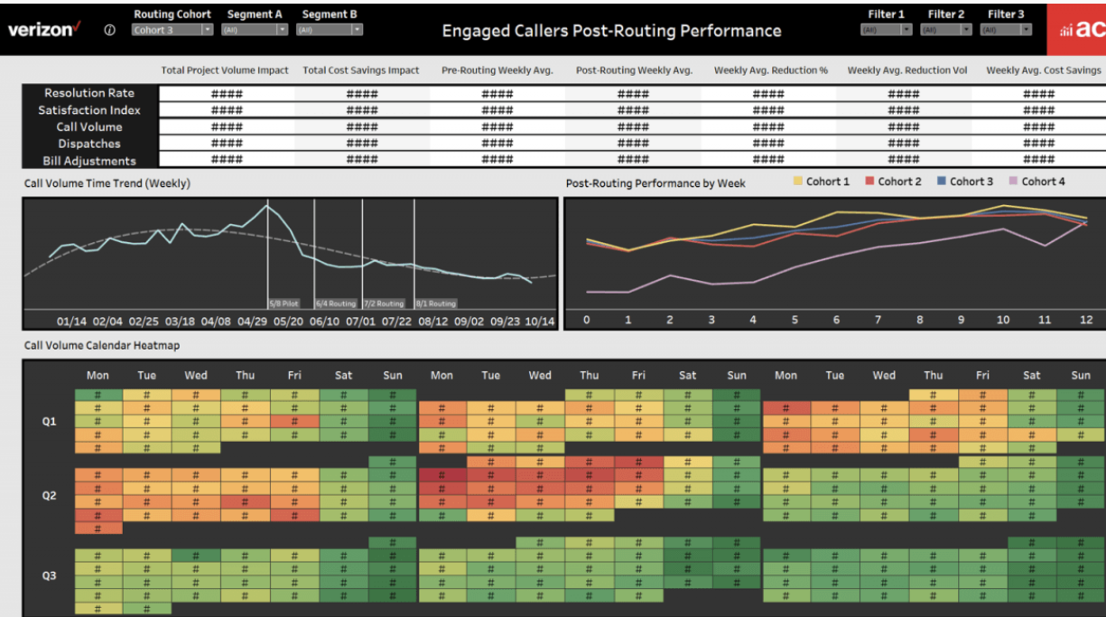

Analytics Center of Excellence scales analytics process for digital and call center operations

Verizon Fios used manual Excel tables to analyze data like digital and call center metrics. Results were distributed to several teams in static reports. Joining data before analysis also proved tricky with multiple sources to pull from: Oracle, Hadoop, and Teradata. Having limited analytics resources, but a large set of diverse stakeholders to serve, this was an inefficient process that created bottlenecks and redundancies and prevented users from easily digesting data to answer their questions. Gregory McConney, Associate Director of Contact Center Analytics explained how analytics staff “strive to perform advanced analytics and build predictive models and machine learning solutions that enable the business to move forward...We don’t want to create basic insights when business stakeholders can do that themselves.”Verizon dedicated talent and attention to creating an Analytics Center for Excellence (ACE). The 80+ person team has nearly 30 members who perform analysis in Tableau and deliver insights to key stakeholders. Other members support data governance, data prep, and modeling before handing off to Tableau developers and server administrators. “The first thing we do is structure the data correctly for it to scale and be automated. We put a lot of thought on structuring the data right and building views on top that will distribute information in the most intuitive way,” explained Sid Dayama, Senior Manager of Data Analytics for Verizon.Before building suites of dashboards, ACE held planning sessions with stakeholders to determine needs. They developed dashboards optimized for fast load times, supporting more effective discussions that transformed how they make decisions from the top down.Once everyone began to embrace the dashboards, the team became more efficient at finding insights with features like tooltips, reflecting details within the visualizations and clarifying field definitions. They look forward to embracing other platform features and using different chart types to further strengthen the customer experience.

Call center increases capacity, improves customer routing and sentiment with 50% faster analysis time

Customers interact with Verizon’s support team in a few ways—through online chat, call centers, and cross-channel, which means starting in digital channels and ending in a call center. However, Verizon wanted customers to self-serve digitally and avoid the call centers so they don’t have to wait for answers or a tech visit, keeping satisfaction levels high. More importantly, they didn’t want repeated call center contact because that meant a problem was unresolved, producing lower efficiency and higher operational costs within the call center and dispatch teams.Understanding that different segments of customers have varying calling behavior, ACE built an optimized routing solution for certain cohorts of customers, leveraging Tableau dashboards where teams including business transformation, analytics, IT, and call center operations analyzed customer engagement in call centers and monitored call sentiment.

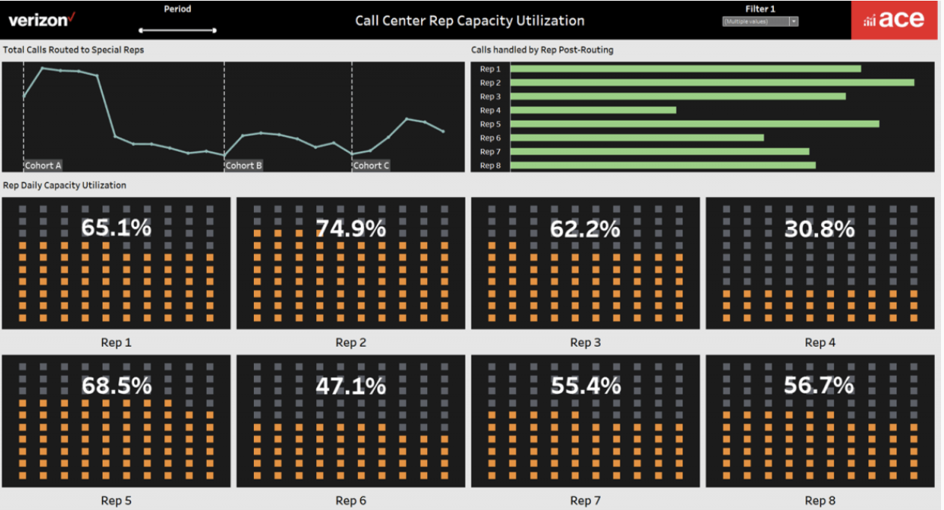

The analytics team analyzes 17 different attributes for each individual person in the customer base, looking at tenure of the customer, what products they use, call drivers, how frequently they call, average handling time, call sentiment upon contact, age, and many more. Customers are then categorized and put into different cohorts for treatment.These individual cohorts are then routed to a special support queue where skilled call center representatives handle requests to avoid repeated problems. Tableau dashboards arm the call center reps with contextual information such as historical calling patterns of the customers they are handling so they can resolve issues effectively and reduce the need for customers to call multiple times.The team used the alerts feature in Tableau to notify them when the call volume goes down below the conditional visual threshold. And when it does, an algorithm is activated to reveal new sets of high-request customers and trigger a new customer list for the representatives.“It's basically taking the human element out of all of this, which is amazing,” explained Greg.

Having situational awareness of the customers calling behavior and operational capacity for call center staff, Verizon improved their effectiveness when handling customer calls, reduced the number of repeated calls, and achieved a 43 percent reduction in call volume. Tableau dashboards also reduced customer service analysis time by 50 percent with quicker resolution of customer issues. The dashboards are used by high-level managers to develop strategy as well as stakeholders on the front lines who answer calls daily and need to identify calling behaviors, patterns, and historical trends.

Geospatial mapping in Tableau helps team monitor impact of service dispatches

In Verizon Fios, there have been certain households that require multiple dispatches to their homes to resolve issues. In order to help reduce the need for multiple dispatches and improve customer satisfaction the ACE team built a suite of Tableau dashboards that helps dispatch teams monitor a geographical impact of field technician dispatch activity not only at the state and zip code level, but also at the individual household level.The dashboards analyzed dispatch activity for 6.9 million Fios customers and included KPIs such as number of tickets generated, ticket rate, dispatches initiated, overall dispatch rate—and also investigated the cost impact from these dispatches. several other wireline infrastructure attributes. several other wireline infrastructure attributes. several other wireline infrastructure attributes. several other wireline infrastructure attributes. several other wireline infrastructure attributes. several other wireline infrastructure attributes. several other wireline infrastructure attributes. several other wireline infrastructure attributes. several other wireline infrastructure attributes. 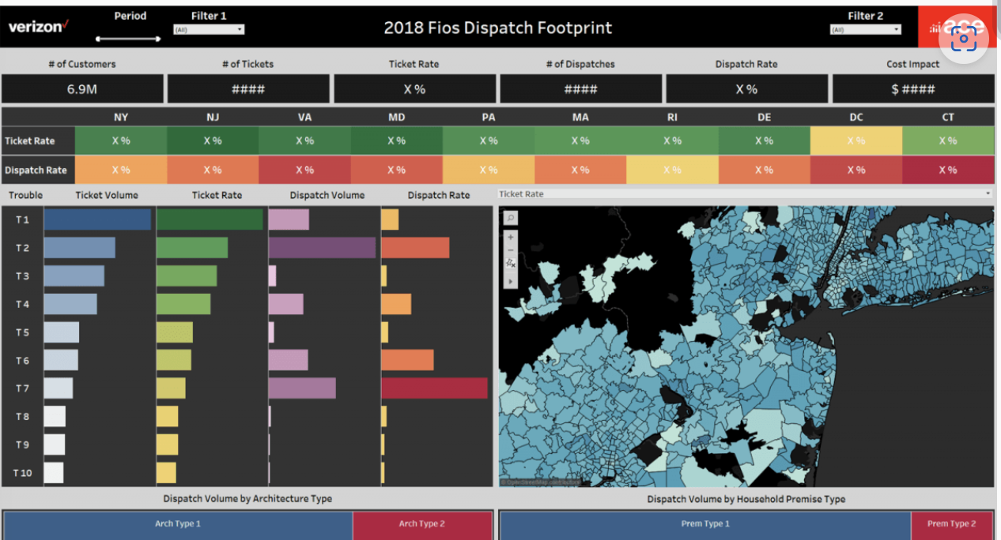

Mapping features in Tableau, like the Mapbox integration, allowed the team to identify a location-based impact through heat maps and revealed where ticket and dispatch rates over-performed or under-performed and what variables led to the frequent dispatches.Consequently, Verizon reduced technician dispatch analysis time by more than 50 percent and discovered how geospatial mapping can support other organizational needs.